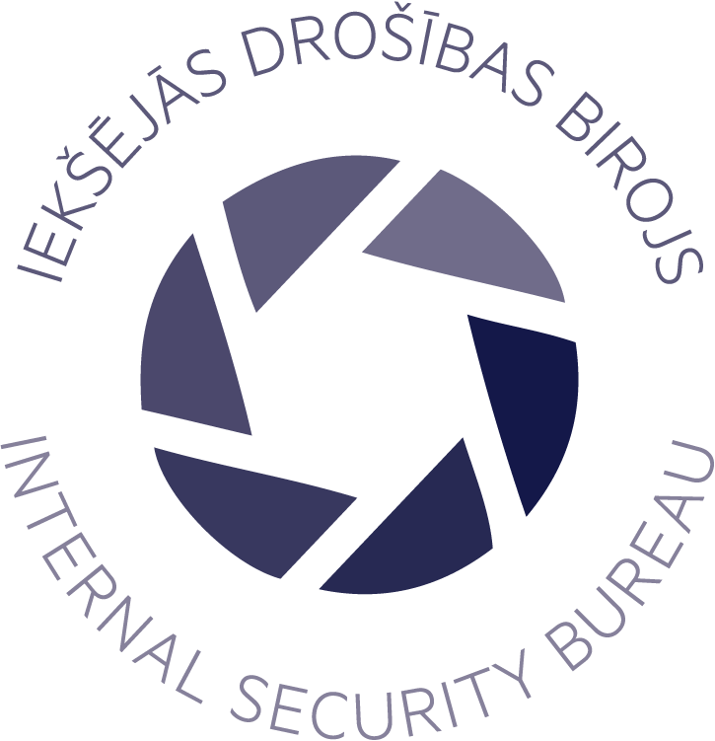 |  | Internal security bureaU  Established on 1 November, 2015
values  - Highly professional personnel  considerable resources are invested in the staff training process  - Well-grounded decisions  decisions are made by competent officials and employees  - Crime prevention  a lot of effort is put not to allow commitment of offences  - Independent, impartial detection and investigation of criminal offences  no external influence is allowed while detecting and investigating offences  - Public trust  the public is informed about the Bureau’s activities to gain the citizens’ trust  - Planning of long-term development  plans are designed for considerable periods of time to ensure the Bureau’s constant development  contact information  Hotline  +371 67209055  Home page  www.idb.gov.lv  E-mail  International.requests@idb.gov.lv  staff  Personnel 97 |  | legal status and main task  On 1 November 2015, the Internal Security Bureau Law came into force, by which the Internal Security Bureau was established under the supervision of the Minister for the Interior.  The task of the Bureau is to ensure the rule of law and impartiality in detecting and investigating crimes committed by particular officials and employees from subordinate institutions (except the State Security Service) of the Ministry of the Interior and local governments, the Port Police and detention centres, thereby enhancing society’s trust in public administration.  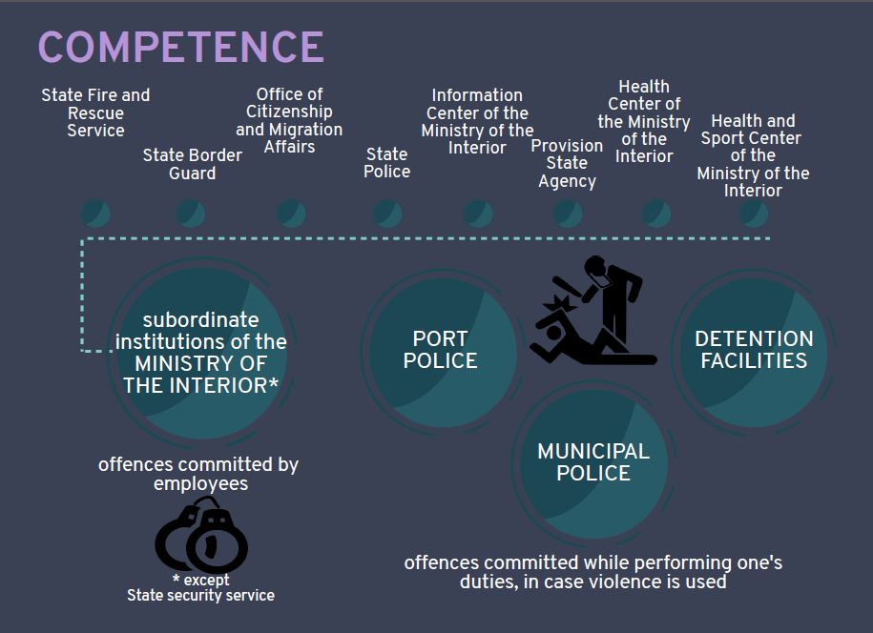  By establishing the Bureau as an institution under the supervision of the Minister for the Interior, the principle of independent investigation is ensured in terms of institutional hierarchy as well as independence in thorough evaluation of evidence.  According to the Law of the Republic of Latvia, the scope of competence of the Internal Security Bureau includes, inter alia, detection, investigation and prevention of the criminal offences (including the corruption-related ones) committed by particular officials in State Authority Service.  Corruption crimes are investigated also by the Corruption Prevention and Combating Bureau, State Border Guard, State Police and State Security Service in Latvia.

statistics on crime investigation
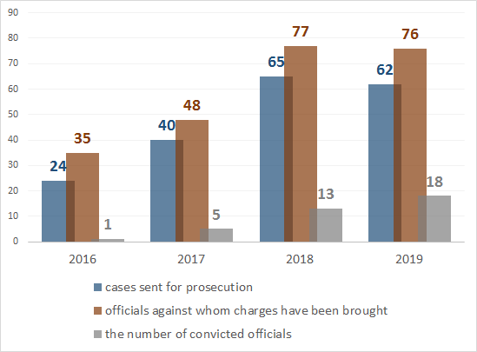

crime prevention
Internal security bureau has developed Methodology of Assessment of internal security risks.
The aim is to assess the operation of the Bureau and to give a tool for the institutions subordinated to the Ministry of the Interior in order to raise their capacity and help to identify:
- functions related to specific security risks, including corruption risks;
- risks related to regulatory framework governing the operation of the institution;
- risks related to personnel.
As the result of the risk assessment, preventive measures are prepared to prevent the detected risks.

The Internal security bureau’s activities are aimed at ensuring Public involvement:
- encourage reporting;
- educate the public and raise awareness;
- build institution’s image (ensuring the rule of law).

For officials — measures ensuring legal compliance:
- educating;
- control.

On annual basis, the Internal Security Bureau presents lectures to both operating and potential employees of the institutions subordinated to the Ministry of the Interior with the aim to ensure lawfulness of their activities and draw attention to the detected problem situations. Current problems are discussed at annual conferences in cooperation with representatives of the prosecution office, courts, human rights protection and law enforcement agencies to improve the prevention and investigation of violence-related crimes committed by officials on duty.

AGENCY’S ACTIVITIES
Over the period of several years, the Internal Security Bureau has succeeded in achieving its initially defined goals: its popularity and public trust have been gained – the number of the received reports/complaints grows from year to year – in 2019 more than 1300 reports/complaints were received. Various prevention and investigation measures have resulted in improvement of the control of the financial activities and overall operation of the institutions subordinated to the Ministry of the Interior.

The activities of the Internal Security Bureau have been appreciated also by international organizations – in 2019 Head of the Bureau participated in a meeting of Ministers’ Deputies of the Committee of Ministers of the Council of Europe and a meeting of the UN Committee against Torture where he informed the audiences about the Bureau’s competence and operation results in Latvia.

chalanges
The Internal Security Bureaus’ challenges for the future period of time include the increase in its scope of competence, considering the recommendations from international institutions; raising its capacity in investigation of financial crimes, as well as the development of the Bureau’s information maintaining and processing system.

